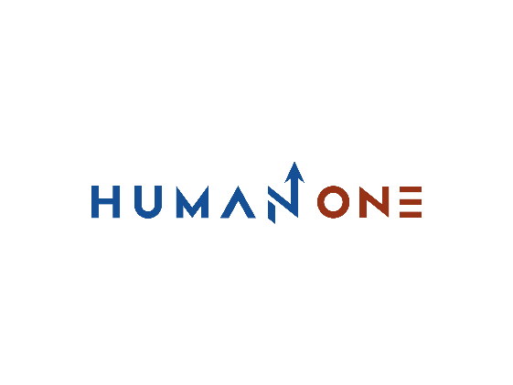

Services

Expertise

**EN**

**FR**

Get in touch

Company

Services overview

Consulting

Engineering

Technology



Operations

Teams

# Development Teams

For the development of your projects, we can compose teams of expert consultants who will support your internal team. Our consultants share the same culture of innovation and product focus. If your need is for dedicated developers, HumanOne becomes your natural choice to deploy its consultants and developers to create or co-create your solution or improve it once it is operational. We guarantee you all the elements (expertise, flexibility, recruitment, management and motivation of your development team) necessary for the success of your project.

Let’s Talk

## **Our approach to building dedicated software teams**



Expand

Strengthen cooperation, apply the best quality processes and pursue operational efficiency



Develop

Installing communication systems, supporting and enhancing processes while complying with safety requirements and standards



Ramp up

Development of a detailed roadmap to launch recruitment, knowledge sharing and team onboarding



Setting up the Human Resources

Identify the necessary skills, select the candidates and shape the team structure

Recruit the best developers, optimize your schedules and master the project steps



## **Get development talent with experience in recent technologies**

**Programming Languages**

       

**Mobile development platform**

Mobile development platforms

  

**Advanced technologies**

  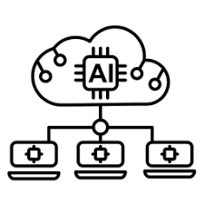  

**Cloud ecosystem partnership**

  

## **Quick facts about HumanOne**



At HumanOne, we offer a unique combination of experience, personal dedication, and expertise in the most innovative technologies to ensure the best possible customer experience. We make the employee experience our main lever to create a motivating work atmosphere based mainly around our human capital. That's why we maintain our experts with a high degree of employability and expertise. And because you entrust us with your valuable technological projects, we respond to this trust with the excellence of our engineering services.

**100% 2-4 weeks**

 

**2-4 weeks**

**To start a dedicated team**

**74%**

**Middle to senior developers**

## **Why choose HumanOne?**

**Mature talent pool**

We are always looking to deliver next-generation technologies that make extensive use of microservices. Our agile frameworks stay ahead of the constantly changing market demands, allowing us to perpetually evolve and grow our solutions.

**Cross-sectoral expertise**

HumanOne's expert teams of developers, analysts, designers, managers and compliance experts will help you enrich your project with cutting-edge expertise in the FinTech, automotive, telecom and healthcare sectors.

**Facilitate your HR**

HumanOne offers you the opportunity to focus on the important business aspects of your activity. This way, we optimize the time and budget allocated to your project. We take care of the composition, management and motivation of your consulting teams throughout your project.

**A strong engineering culture**

Control the entire engineering cycle of your project by leveraging our vast network of technology consulting experts, our various cloud partnerships and centers of excellence to ensure an optimal software development lifecycle

### **Every instant security**

Enable you to take advantage of an optimal combination of product and service quality that aligns with distinguished security standards and industry regulations and provides the most comprehensive protection for your data and your customers' data.

**Perfect supervised team**

Allow access to your internal knowledge enabling the initial alignment of remote engineers with your internal team. with an effective balance between our team's supervision and your control of the overall processes

## **Benefits of building a dedicated development team with HumanOne**

**Deep expertise with Centers of Excellence**

We assist companies in achieving their strategic goals and solving specific problems throughout the project by relying on our centers of excellence as well as our technology offices that can accompany clients in technical decisions.

Optimize the potential of your teams of specialists by continuously participating in knowledge sharing sessions, workshops and personal development activities. We provide you with developers who are ready to go the extra mile by performing the most difficult tasks in product innovation or optimization.

Compose your dedicated software development team based on your exact project needs and desired level of scalability. Depending on your level of commitment to the development process, project management and product ownership, we can set up individualized project governance.

**International standards**

We have a powerful sourcing network that allows us to find the dedicated developers you need in a matter of weeks instead of months. In addition, the flexibility of our organization gives you the same level of control that you have with your internal team.



We master all contractual aspects, payroll elements, team building, employee retention, incentive programs, benefits management, which allows us to organize a rapid implementation of dedicated software teams fully capable of developing and continuously improving your product.



**Flexible scaling of engineering capacity**

Compose your dedicated software development team based on your exact project needs and desired level of scalability. Depending on your level of commitment to the development process, project management and product ownership, we can set up individualized project governance.

We recruit specialized developers from a large talent pool. We also give you the opportunity to choose from targeted profiles within our own teams. Depending on your requirements, we can increase or decrease your dedicated software teams to achieve the optimal ratio between IT resources, budget and development pace.

Compose your dedicated software development team based on your exact project needs and desired level of scalability. Depending on your level of commitment to the development process, project management and product ownership, we can set up individualized project governance.



